ParkEase Project Contribution Report

Name : Banu Priya B

Role: Backend Developer
Problem Statement
Urban drivers face significant frustration and time waste searching for available parking, often without real-time visibility into availability or pricing. This widespread issue leads to increased congestion and a fragmented user experience, with a critical need for an efficient and secure booking platform.
Introduction
I worked on the ParkEase project with a primary focus on the user-side backend architecture and service layer. My responsibilities included developing the core search functionality, the booking engine, and ensuring the secure retrieval of user-specific data through API endpoints.
Key Contributions
- Search & Discovery Logic Implemented the backend search algorithm that allows users to find parking spaces based on geographical location, availability, and pricing. Optimized database queries to ensure fast response times for live parking data.
- Booking Management System Developed the business logic for reserving parking slots. This included handling concurrency (preventing double-booking of the same slot) and managing the lifecycle of a booking from "Pending" to "Completed."
- User Profile & History Services Designed and implemented APIs for managing user profiles and retrieving historical booking data. Integrated these services with JWT authentication to ensure users can only access their own private data.
- Database Schema Optimization Contributed to the refinement of the database schema, specifically focusing on the relationships between Users, Bookings, and Parking Slots to maintain data integrity.

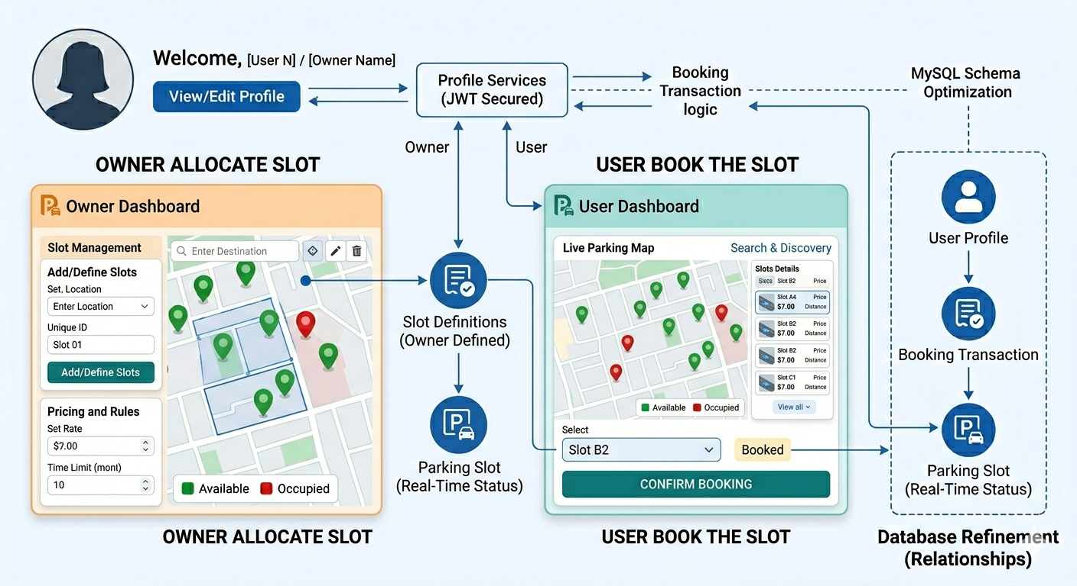

Milestones Summary
- First Milestone: Designed the initial API structure for user profiles and integrated basic search functionality with the MySQL database.
- Second Milestone: Successfully implemented the booking transaction logic and integrated it with the authentication module.
- Third Milestone: Completed full integration of the User Dashboard backend, including real-time slot availability updates and booking history retrieval.

Tools & Technologies Used
- MySQL for relational database management and complex query optimization.
- IntelliJ IDEA for backend development using Java Spring Boot.
- Postman for comprehensive API testing and documentation.
- Git for version control and collaborative development.

